ASSIGNMENTS ON DIGITAL MARKETING

NAME : CYRIL RAJ A
DEPARTMENT : B.E.BIOMEDICAL ENGINEERING
COLLEGE: 8151 DHANALAKSHMI SRINIVASAN INSTITUTE OF
TECHNOLOGY
NAANMUDHALVAN COURSE : DIGITAL MARKETING
NM TEAM ID : NM2023TMID02352
NM ID : 3AA8E10F8A17FBDAED24EABF1627636A

ASSIGNMENT 1:
Create a blog or website using Blogspot and WordPress. Customize
The theme design and post new article with 500 words.
Website: https://darkseidpcbuilds4.wordpress.com/2023/10/18/the-rise-of-darkseid-pc-crafting-dreams-one-pc-at-a-time/

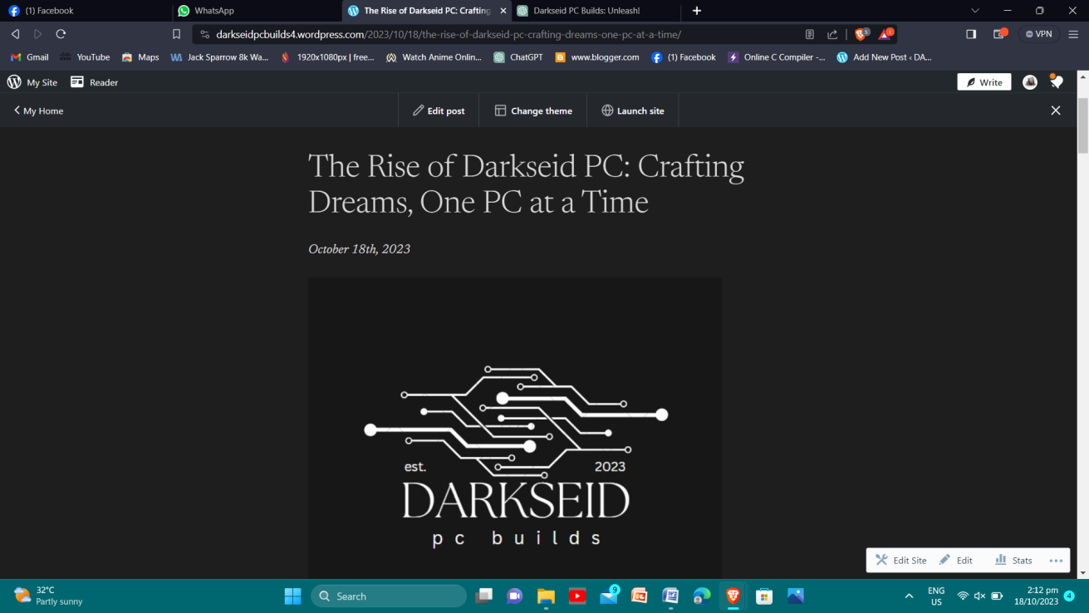

ASSIGNMENT 2:
Create a new Facebook business Page and Post one social media poster for your brand.
Website: https://www.facebook.com/profile.php?id=61550870367340

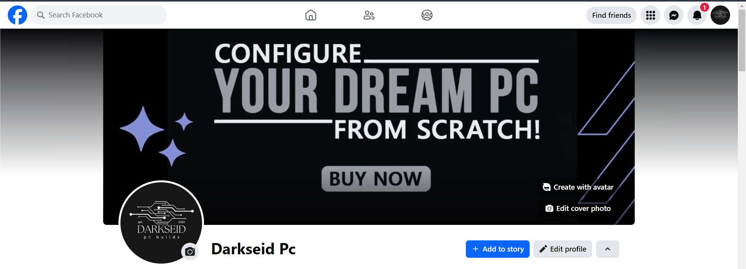

ASSIGNMENT 3:
Create and design a social media advertisement poster using Canva

. 

ASSIGNMENT 4:
4.Create email newsletter design using MailChimp or Canva tool.



